1 Install Android Studio and Packages: Download Android Studio from the below link : https://developer.android.com/studio   
  
2 Configure Android SDK packages: Go to Tools ◊ SDK Manager:

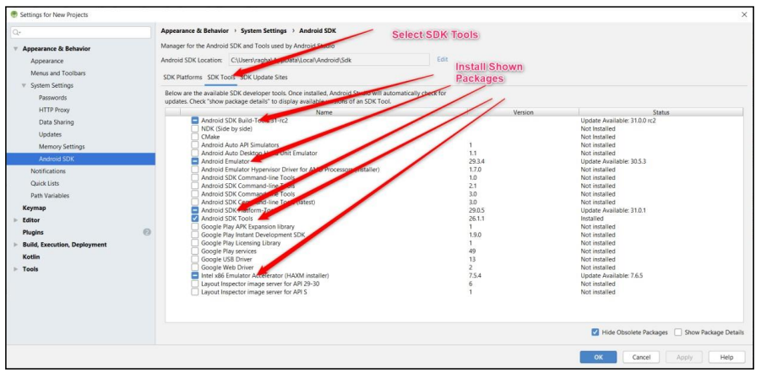

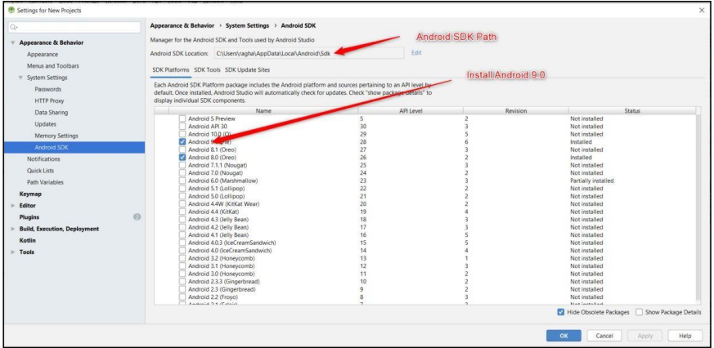

3 Creating Emulator Go to Tools ◊ Select AVD Manager  
  
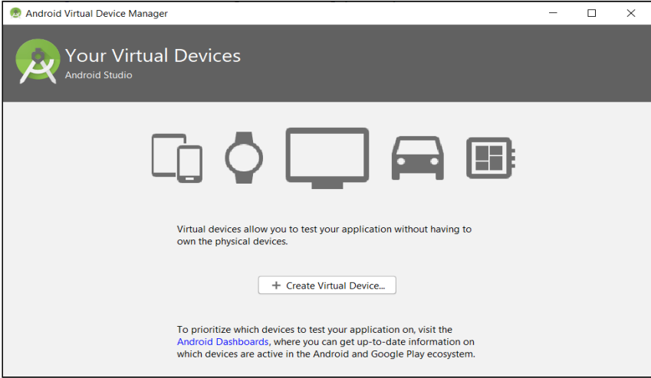  
  
Select Create Virtual Device ◊Select Phone ◊Pixel 2 ◊ Press Next:  
  
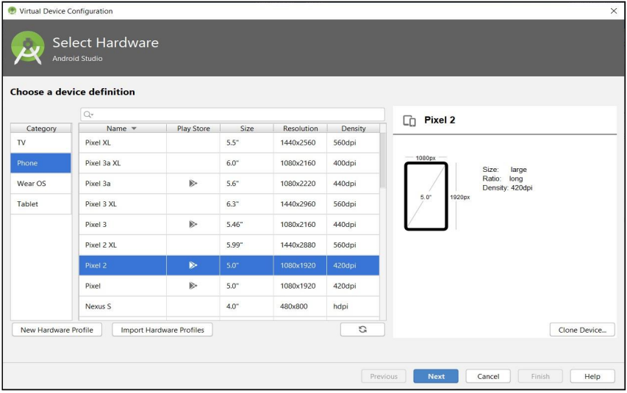  
  
  
Select Android Q, if not already downloaded press download, After download completes Select Q and Press Next Button.  
  
  
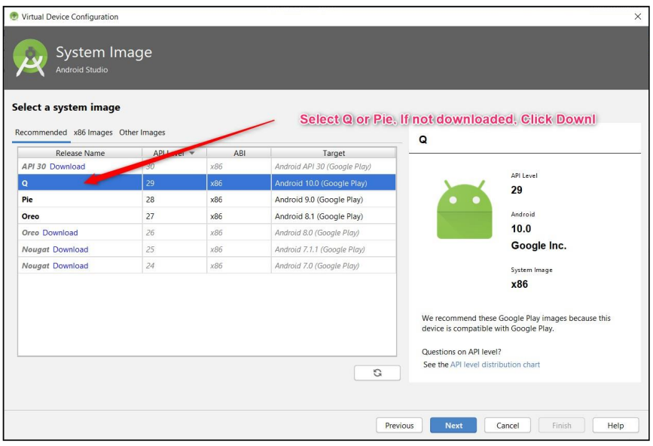  
  
  
Enter AVD Name and Press Finish.  
  
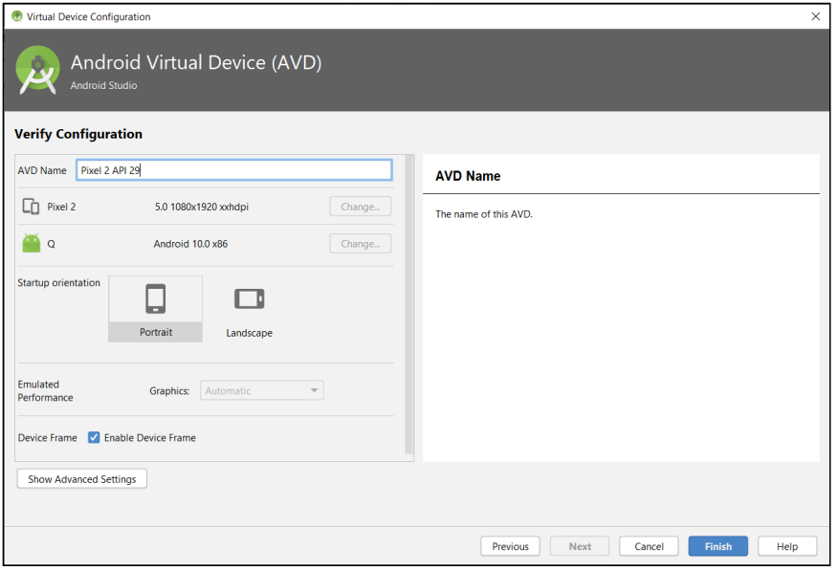  
  
Press Play Button to Start Emulator:  
  
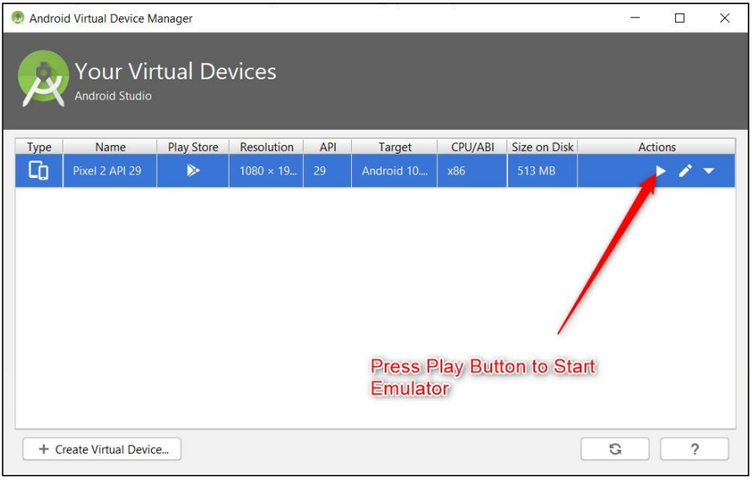  
  
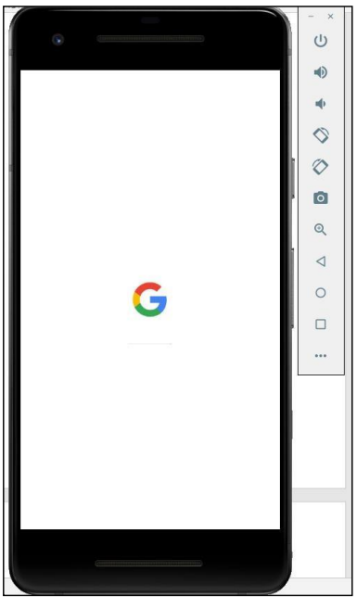  
  
4 Creating a New Project in Android While creating a New Project for First Time, make sure Android Studio is connected to internet. It downloads the required packages from internet. Go to File ◊New ◊New Project:  
  
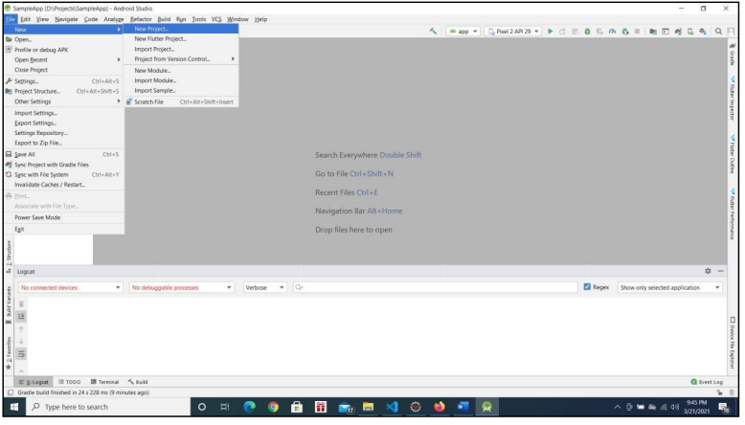  
  
  
Choose Phone and Tablet ◊ Empty Activity ◊ Press Next  
  
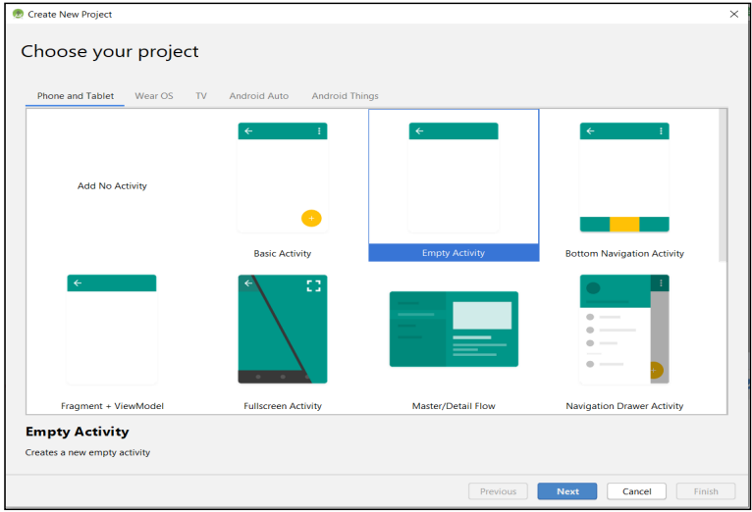  
  
  
In Configure your Project Screen, Enter below details and Press Finish Button. Enter Name of the Application ◊ This will be application name this will be visible with Home Screen Icon. Package Name ◊ Enter package name atleast two identifier (Eg: com.example). Best Practice is 3 or more identifier (Eg: com.example.firstapp). Save Location ◊Location where to save the Project Language ◊ Choose Java Minimum API Level ◊ Android 5.0 Select Checkbox Use androidx.artifacts folder as below screenshot:  
  
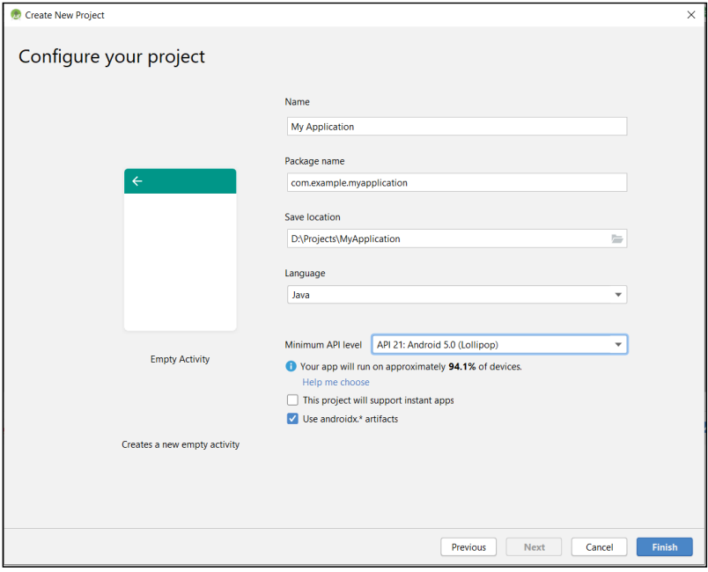  
  
5.Android Project Structure:  
  
  
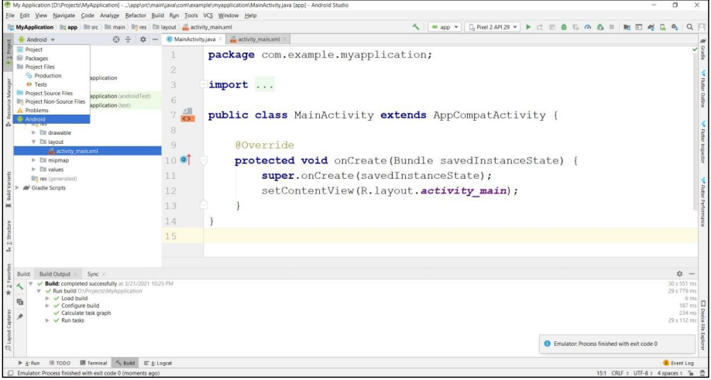  
  
  
Select Project Explorer and Select Android from Project View  
  
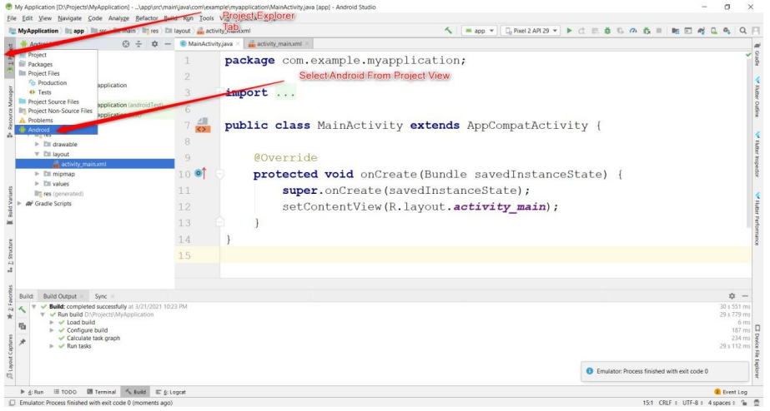  
  
Basic View:  
  
  
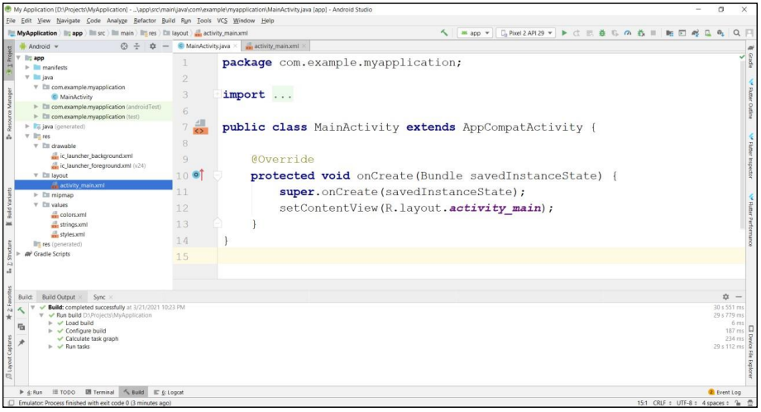  
  
2. Creating an Activity in Android Right Click on Package ◊ New ◊ Activity◊ Empty Activity:  
  
  
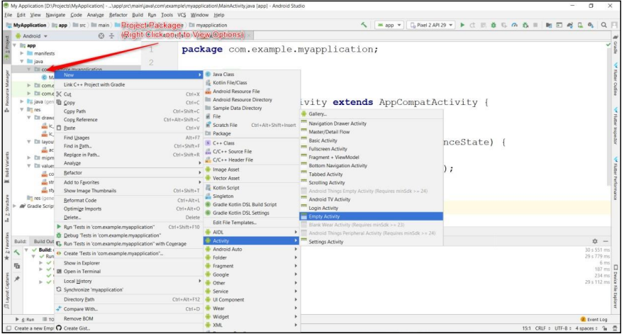  
  
  
Enter Activity Name and Press Finish:  
  
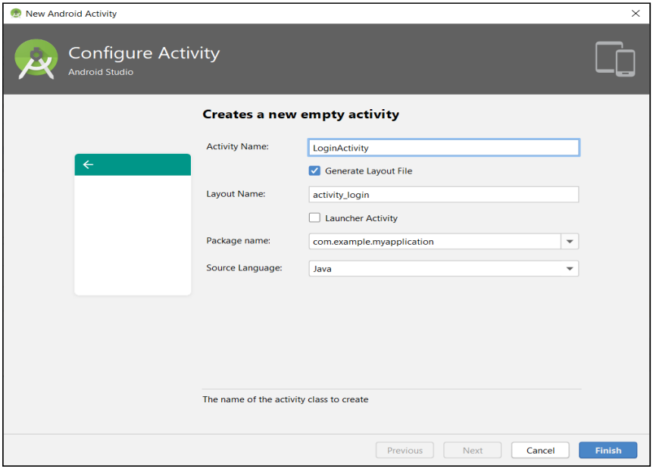  
  
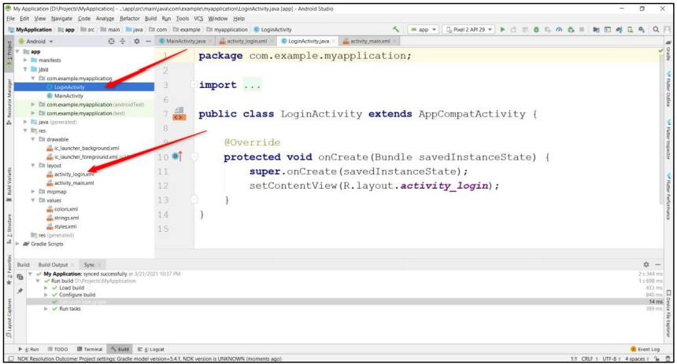  
  
6.Creating a Layout in Android Right Click on Layout Folder ◊ New ◊ XML◊Layout XML File  
  
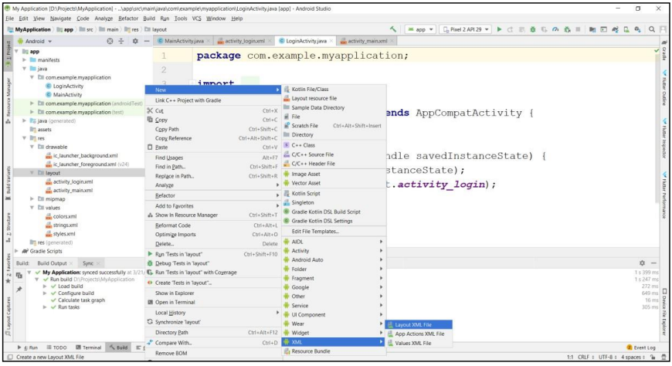  
  
  
Enter xml file name and press Finish:  
  
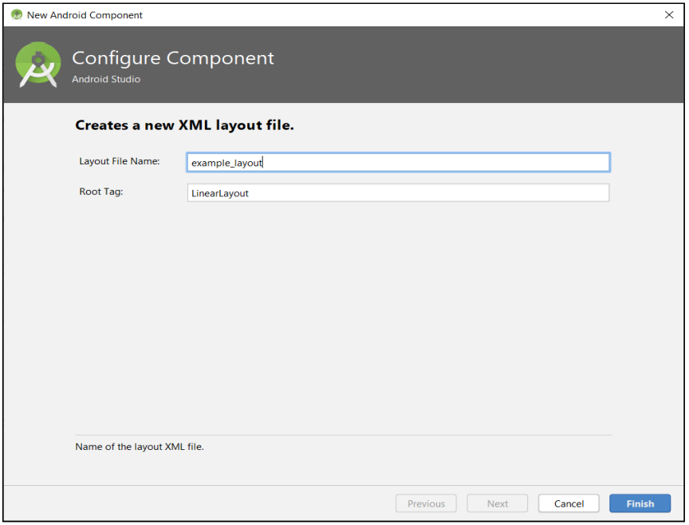  
  
  
  
7 Creating Assets Folder in Android Right Click on app folder ◊ New ◊ Folder ◊ Assets Folder ◊ Press Finish Button:  
  
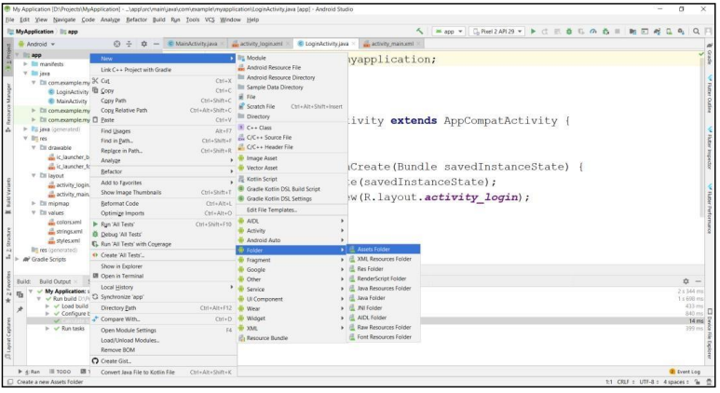  
  
  
  
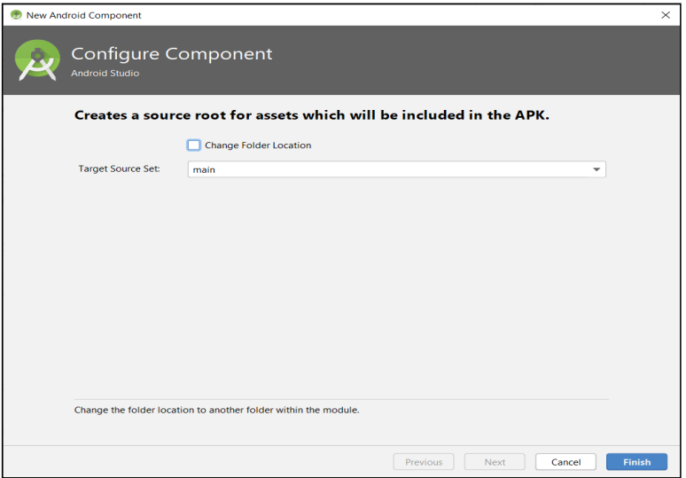  
  
  
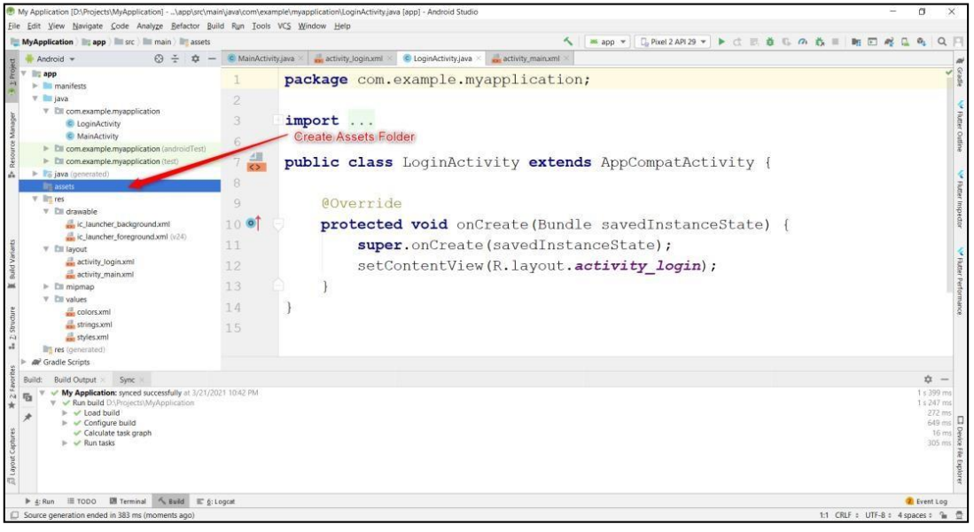  
  
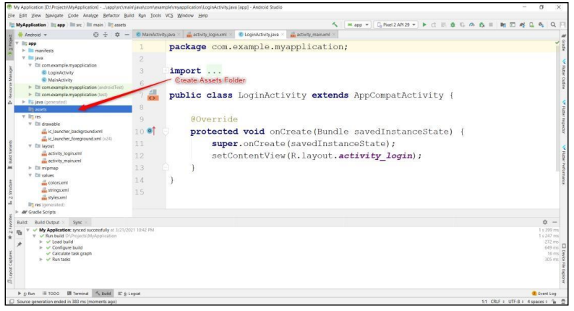  
  
  
  
8 Creating File in assets Folder: Right Click on assets folder ◊ New ◊ File:  
  
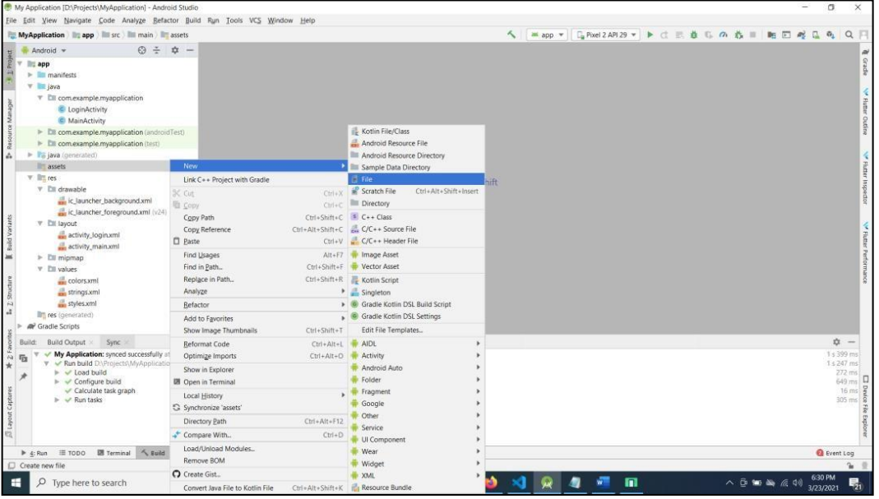  
  
  
Enter filename with extension (Eg: abc.xml):  
  
